

**COMSATS University Islamabad (CUI)**

**Virtual Vehicle Market**

**(Bidding Based)**

***By***

**Abdul Hanan Mughal CIIT/FA17-BSE-003/ISB**

**Muhammad Nadeem Khan CIIT/FA17-BSE-089/ISB**

***Supervisor*Mam Sara Ali**

***Bachelor of Science in Software Engineering (2017-2021)***

**The candidate confirms that the work submitted is their own and appropriate  
 credit has been given where reference has been made to the work of others**.



**COMSATS University Islamabad (CUI)**

**Virtual Vehicle Market**

**(Bidding Based)**

**A project presented to**

**COMSATS University Islamabad**

**In partial fulfillment**

**of the requirement for the degree of**

***Bachelor of Science in Software Engineering (20xx-20xx)***

**By**

**Abdul Hanan Mughal CIIT/FA17-BSE-003/ISB**

**Muhammad Nadeem Khan CIIT/FA17-BSE-089/ISB**

**DECLARATION**

We hereby declare that this software, neither whole nor as a part has been copied out from any source. It is further declared that we have developed this software and accompanied report entirely on the basis of our personal efforts. If any part of this project is proved to be copied out from any source or found to be reproduction of some other. We will stand by the consequences. No Portion of the work presented has been submitted of any application for any other degree or qualification of this or any other university or institute of learning.

|  |  |
| --- | --- |
| Student Name1 | Student Name2 |
| --------------------------- | --------------------------- |

**CERTIFICATE OF APPROVAL**

It is to certify that the final year project of BS (CS) “Project title” was developed by   
**(CIIT/FA17-BSE-003)** and **(CIIT/FA17-BSE-089)** under the supervision of “Mam Sara Ali” and that in her opinion; it is fully adequate, in scope and quality for the degree of Bachelors of Science in Computer Sciences.

---------------------------------------

**Supervisor**

---------------------------------------

**External Examiner**

---------------------------------------

**Head of Department**

**(Department of Computer Science)**

**Executive Summary**

In today’s world, the buying and selling of automobiles (vehicles) are very common and along the buying and selling of cars comes to a lot of frauds and thefts, Documents and details need to be stored, which can be referred later for many reasons including security. Appointing humans for this task involves many problems such as increased employee hiring, accuracy problem, trust, no proof for later use. Talking about the currently available systems, they online provide you with ad posting and showing the mobile number of seller and rest deal can be done by both parties, and no data is stored for later reference in case of frauds or misplacement of the document.

To intercept these problems from prevailing, the Virtual Vehicle Market (VVM) (Bidding Based) is developed. The system has been introduced as a service to deal with the increasing frauds, losing documents, and human error. This system provides a built chat system where both parties can communicate via text and share details once they are comfortable; this helps in reducing unnecessary calls. This system provides the service of storing finalized deals in the system which can be used for later reference.

Virtual Vehicle Market (Bidding Based) is a Buying and Selling platform that allows users to search Vehicle from across Pakistan and choose the vehicle according to their requirements.

**Acknowledgement**

All praise is to Almighty Allah who bestowed upon us a minute portion of His boundless knowledge by virtue of which we were able to accomplish this challenging task.

We are greatly indebted to our project supervisor “Mam Sara Ali”. Without their personal supervision, advice and valuable guidance, completion of this project would have been doubtful. We are deeply indebted to them for their encouragement and continual help during this work.

And we are also thankful to our parents and family who have been a constant source of encouragement for us and brought us the values of honesty & hard work.

|  |  |
| --- | --- |
| Student Name1 | Student Name2 |
| --------------------------- | --------------------------- |

**Abbreviations**

|  |  |
| --- | --- |
| **SRS** | Software Requirement Specification |
| **PC** | Personal Computer |
| SDD | Software Design Document |

Table of Contents

1 Introduction i

1.1 Brief Overview i

1.2 Relevance to Course Modules i

1.3 Project Background i

1.4 Literature Review i

1.5 Methodology and Software Lifecycle for this Project ii

1.5.1 Rationale behind the Selected Methodology ii

2 Problem Definition iii

2.1 Problem Statement iii

2.2 Deliverables and Development Requirements iii

2.2.1 Deliverables iii

2.3 Current System iii

3 Requirement Analysis iv

3.1 Use Cases Diagram(s) iv

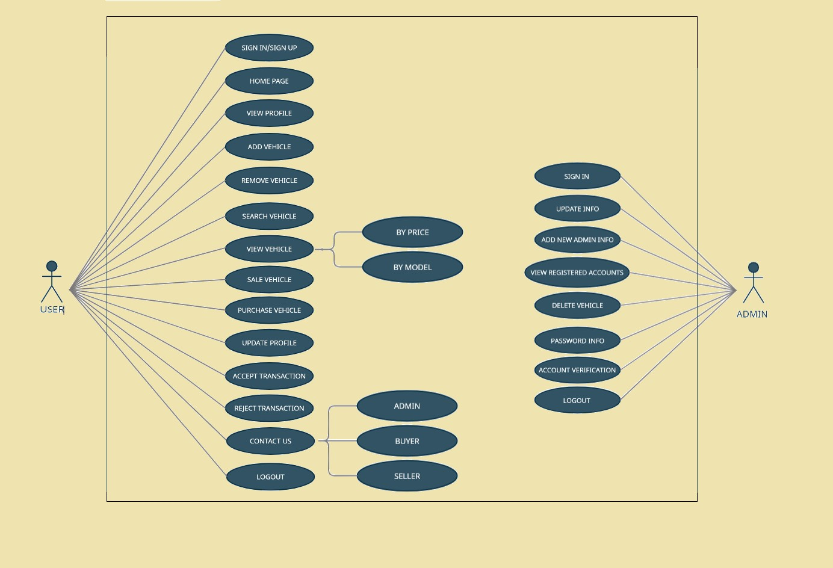 iv

3.2 Detailed Use Case iv

3.3 Functional Requirements xviii

3.3.1 SIGN-UP xviii

3.3.2 PASSWORD xviii

3.3.3 UPLOAD PROFILE PICTURE xix

3.3.4 UPLOADING DETAILS xix

3.3.5 ACCOUNT APPROVAL xx

3.3.6 SIGN-IN xx

3.3.7 ADD VEHICLE xxi

3.3.8 EDIT POST xxi

3.3.9 VIEW PROFILE xxii

3.3.10 UPDATE INFORMATION xxii

3.3.11 DELETE POST xxii

3.3.12 DELETE PROFILE xxiii

3.3.13 FORGOT PASSWORD xxiii

3.3.14 VIEW BUYER PROFILE xxiv

3.3.15 REQUEST FOR TRANSACTION xxiv

3.3.16 SEARCH VEHICLE xxv

3.3.17 SEARCH VEHICLE BY PRICE xxv

3.3.18 VIEW VEHICLE DETAILS xxvi

3.3.19 VIEW SELLER PROFILE xxvi

3.3.20 RESERVE VEHICLE FOR INSPECTION xxvii

3.3.21 Contact Seller xxvii

3.3.22 REQUEST TRANSACTION TO SELLER xxviii

3.3.23 Signing the Contract xxviii

3.3.24 UPLOAD TRANSFER REGISTERY DOCUMENT PICTURE xxix

3.3.25 VIEW TRANSACTION HISTORY xxix

3.3.26 CONTACT ADMIN xxix

3.3.27 ADMIN LOGIN xxx

3.3.28 ADD ADMIN xxx

3.3.29 ADD DETAILS FOR ADMIN xxxi

3.3.30 DELETE ADMIN xxxi

3.3.31 Delete User xxxii

3.3.32 Accept User xxxii

3.3.33 View Registered Users xxxiii

3.3.34 Sign-out xxxiii

3.4 Non-Functional Requirements xxxiv

3.4.1 Usability xxxiv

3.4.2 Performance xxxiv

3.4.3 Security xxxiv

3.4.4 Availability xxxiv

4 Design and Architecture xxxiv

4.1 System Architecture xxxv

4.2 Process Flow/Representation xxxv

4.3 Design Models xxxv

4.3.1 Diagrams xxxv

• Sign in/Sign up xxxvi

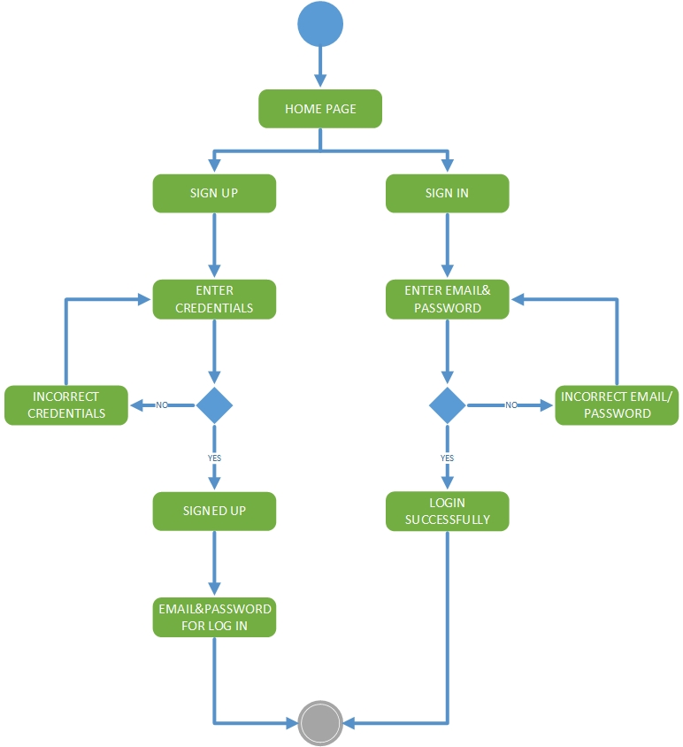 xxxvii

• Update Post xxxviii

• Update Profile & Password xxxix

• Transaction Request xl

• Forgot Password xli

• Smart Contract xlii

• Bidding xliii

5 Implementation xlviii

5.1 Algorithm xlviii

• Signup implementation: xlviii

• Sign Smart Contract: xlviii

Software requirements traceability matrix xlviii

Human interface design l

5.2 User Interface l

6 Conclusion and Future Work li

6.1 Conclusion li

6.2 Future Work li

7 References li

# 

# Introduction

## Brief Overview

We are developing this web app to help vehicle dealers/companies and general people. With this app they can easily sell/buy vehicles and transfer ownership of the vehicle. This app will provide verified cars and motorcycles and also a secure transfer of money and ownership. We aim to provide a hustle free market of vehicles to everyone who are tired of the traditional and tiring physical market.

Virtual Vehicle Market is web/phone app which will provide only verified vehicles to buyers and a secure way to transfer money and the ownership the vehicle. It will have a standard and easy installment program for the people who do not have money to pay at one time. Through VVM we will try to provide the desired vehicle to buyer so that he does not have to go anywhere else. This app will provide a real time communication between the seller and buyer.

* The System would help both buyer and seller in Vehicle Dealing.
* The System would provide chat app where both parties can communicate via text and images.

## Relevance to Course Modules

We have studied HTML5, CSS3, and JS in our course Web Engineering, which we have used here in our project Designing. We have implemented the iterative Methodology, which we have studied theoretically in our Software Requirement Engineering Course.

## Project Background

In this project, we will build a web app that will enable the user to post ads, communicate through webs own chat application and then finalize the deal. It also have a bidding system in which different customers will bid on a specific vehicle and user with highest bid will buy that particular vehicle.

## Literature Review

The related system PakWheels.com also provides such a platform for the buyer and seller of the vehicle. They also offer a wide range of data to the user and contacting sellers would be through their provided phone number on the website/account.

## Methodology and Software Lifecycle for this Project

In this Project, Iterative Development Methodology will be followed. We will complete modules in iterations.

### Rationale behind the Selected Methodology

We have used iterative Methodology, as our system was subdivided into different modules, and each module had a link to other modules. Hence, starting from a basic model and building a complex model was our goal, so we used an iterative model. The risk assessment will be easy, and testing will be easy as well.

# Problem Definition



## Problem Statement

All the available system works on the same business model that would allow the user to post an ad and the buyer would be shown user mobile number so they can contact on their own and deal, this sometimes create an unpleasant experience for buyer or seller and sometimes both. There is no track of the finalized deal data on the system. All the available systems are only classified ads website. Although people tend to buy the vehicle in person and look for the traditional way, this platform provides a wide range of vehicles to look from.

## Deliverables and Development Requirements

Following are the deliverable:

### Deliverables

* Project Scope Document
* Software Requirement Specification Document (SRS)
* Software Design Document (SDD)
* 40% implementation

## Current System

PakWheels also provides such a platform for the buyer and seller of the vehicle. They also offer a wide range of data to the user, and contacting sellers would be through their provided phone number on the website/account.

**Table ‎2.1: Sample Table**

|  |  |  |
| --- | --- | --- |
| **Application Name** | **Weekness** | **Solution** |
| Pakwheels.com | This system does not use bidding system. | Our application will used bidding through which users can bid on specific vehicle. |

# Requirement Analysis

The following parts of Software Requirements Specification (SRS) report should be included in this chapter.



## Use Cases Diagram(s)

## 

## Detailed Use Case

#### USER SIGN UP

|  |  |
| --- | --- |
| **Use Case ID:** | UC-1 |
| **Use Case Name:** | User Sign up |
| **Actors:** | Buyer, Seller |
| **Description:** | User can sign up to create an account, which is mandatory to use the website. |
| **Trigger:** | User clicks on the ‘Sign up’ button to get register on website. |
| **Preconditions:** | * The user has a stable and working internet connection. * User must have a valid email for registration. |
| **Postconditions:** | User receives a confirmation email on provided email. |
| **Normal Flow:** | * User navigates to the home page of website. * The user clicks on the sign-up button. * The system ask the user to choose an option of buyer or seller. * User enters the required information and confirm submission. * System send a request to the server for new registration. |
| **Exceptions:** | The system will prompt the user to re-enter the correct details. |
| **Business Rules** | On clicking send the credentials would be sent to admin for manual verification. |
| **Assumptions:** | * The user will have a stable internet connection. * The user has not already registered for the specified role. |

#### USER SIGN IN

|  |  |
| --- | --- |
| **Use Case ID:** | UC-2 |
| **Use Case Name:** | User Sign in |
| **Actors:** | Buyer, Seller |
| **Description:** | Registered user can sign in to their account to use website. |
| **Trigger:** | User enters his mail and password and press sign in button. |
| **Preconditions:** | User is already registered with the system. |
| **Postconditions:** | User enters correct credentials and is logged in to the account and redirects to the home page of website. |
| **Normal Flow:** | * A user enters the correct login credentials clicks on the Sign in button. * Log in access is granted to the user and redirects the user to the timeline page upon successful validation of information. |
| **Alternative Flows:** | * User enters the incorrect information. * System validates the information and redirects the user the sign-in page.The system will prompt the user to sign-in with new credentials. |
| **Exceptions:** | • Internet disconnected while the server request for validation. |
| **Assumptions:** | User is already registered with the system. |

#### VIEW PROFILE

|  |  |
| --- | --- |
| **Use Case ID:** | UC-3 |
| **Use Case Name:** | User View profile |
| **Actors:** | Buyer, Seller |
| **Description:** | User can sign in to the website and view his profile. |
| **Trigger:** | User clicks on the profile button to view his profile. |
| **Preconditions:** | User has to sign in to his account. |
| **Postconditions:** | User gets to see his profile. |
| **Normal Flow:** | User clicks on the view profile button. |
| **Business Rules** | Profile View of user would be shown to the user. |
| **Assumptions:** | User is logged in to his account. |

#### CHANGE/RESET PASSWORD

|  |  |
| --- | --- |
| **Use Case ID:** | UC-4 |
| **Use Case Name:** | Change password |
| **Actors:** | Buyer, Seller |
| **Description:** | User can change their password given that they have access of their email address that is registered with the provided email. |
| **Trigger:** | User clicks on the Change password button. |
| **Preconditions:** | • The user is already registered with the system. • User has access to their email account. |
| **Postconditions:** | The password of the user’s profile is changed. |
| **Normal Flow:** | * User clicks on the Change password button. * User enters the current password. * User enters the new password. * User re-enters the new password. * User er clicks on the OK button. * User’s password is changed. |
| **Exceptions:** | Internet disconnected while the server request was made. |
| **Business Rules** | The user must have an account, an old password, and access to his/her email. |
| **Assumptions:** | * The user is logged in. * Working internet connection. |

#### ADD VEHICLE

|  |  |
| --- | --- |
| **Use Case ID:** | UC-5 |
| **Use Case Name:** | Add Vehicle |
| **Actors:** | Buyer, Seller |
| **Description:** | Seller added his vehicle for sale. |
| **Trigger:** | User clicks on the Post button after adding his vehicle. |
| **Preconditions:** | * User must have a working internet connection. * Uer has all the credentials required about vehicle to post. |
| **Postconditions:** | User vehicle is added. |
| **Normal Flow:** | * User clicks on the add button and enter vehicle details. * User upload the pictures of his vehicle. * User can press submit button. |
| **Exceptions:** | If all the steps of the normal flow are not followed, the user will not be able to add his vehicle. |
| **Business Rules** | The user has a good condition vehicle for sale. |
| **Assumptions:** | User provides all the details. |

#### VIEW VEHICLE

|  |  |
| --- | --- |
| **Use Case ID:** | UC-6 |
| **Use Case Name:** | View Vehicle |
| **Actors:** | Buyer |
| **Description:** | User gets to view the details and review about vehicles added to the site. |
| **Trigger:** | User clicks on the View details button. |
| **Preconditions:** | User must have a working internet connection. |
| **Postconditions:** | Details of all vehicle are displayed to the user. |
| **Normal Flow:** | * User clicks on the view details button. * Details of vehicle are displayed to the user. |
| **Exceptions:** | User will be registered himself as a buyer. |
| **Assumptions:** | Working internet connection. |

#### SEARCH VEHICLE

|  |  |
| --- | --- |
| **Use Case ID:** | UC-7 |
| **Use Case Name:** | Search Vehicle |
| **Actors:** | Buyer |
| **Description:** | User search for his favourite vehicle that either car or bike. |
| **Trigger:** | User clicks on the search button or bar. |
| **Preconditions:** | User must have a working internet connection. |
|  | User know the name and model of the desired vehicle. |
| **Postconditions:** | Details will be displayed to the user if it is added by some seller. |
| **Normal Flow:** | User clicks on the search button.  User inputs the name of the vehicle which he wants.  The system searches the vehicle.  Details will be displayed to the user. |
| **Exceptions:** | Vehicle is not available. |
| **Assumptions:** | User doesn’t know the correct spelling of the car. |

#### SEARCH BY PRICE

|  |  |
| --- | --- |
| **Use Case ID:** | UC-8 |
| **Use Case Name:** | Search by Price |
| **Actors:** | Buyer |
| **Description:** | Buyers will be able to search a vehicle by price. |
| **Trigger:** | Buyer clicks on the Price button in categories. |
| **Preconditions:** | User is on the vehicle catogory page. |
| **Post-conditions:** | Vehicle with the selected price range will be displayed. |
| **Normal Flow:** | * User clicks on the price category. * System will displays different price ranges of vehicles. * User clicks on the desired price range. |
| **Alternative Flows:** | * User enters a starting price range in the upper search box and ending price range in the lower search box. * The user clicks on the Search button. |
| **Exceptions:** | No car available in the desired price range. |
| **Assumptions:** | User is a buyer. |

#### SEARCH BY MODEL

|  |  |
| --- | --- |
| **Use Case ID:** | UC-9 |
| **Use Case Name:** | Search by Model |
| **Actors:** | Buyer |
| **Description:** | User will be able to search vehicle with the desired model. |
| **Trigger:** | User clicks on the Model button in categories. |
| **Preconditions:** | User is on the vehicle category page. |
| **Post-conditions:** | Vehicles with the desired model will be displayed. |
| **Normal Flow:** | * User clicks on the model category. * System will displays different models of vehicles. * User clicks on the desired model of vehicle. |
| **Alternative Flows:** | 1. User enters a model and name of vehicle in search bar. 2. User clicks on the Search button. |
| **Exceptions:** | No car available of the desired model number. |
| **Assumptions:** | User is a buyer. |

#### PURCHASE VEHICLE

|  |  |
| --- | --- |
| **Use Case ID:** | UC-10 |
| **Use Case Name:** | Purchase Vehicle |
| **Actors:** | Buyer |
| **Description:** | Buyer will start the contract for purchasing from the seller. |
| **Trigger:** | Buyer clicks on the Purchase button. |
| **Preconditions:** | User is signed in to the system. |
| **Post-conditions:** | Seller will get a notification that someone has reserved his vehicle. |
| **Normal Flow:** | * User clicks on the Purchase button. * Seller will accept the request from buyer. |
| **Exceptions:** | Seller rejects the reservation request. |
| **Assumptions:** | User has liked the vehicle and its specifications as described in the details. |

#### REMOVE VEHICLE

|  |  |
| --- | --- |
| **Use Case ID:** | UC-11 |
| **Use Case Name:** | Remove Vehicle |
| **Actors:** | Buyer, Seller |
| **Description:** | Seller removes the vehicle. |
| **Trigger:** | User clicks on the remove button. |
| **Preconditions:** | User has uploaded the vehicle before. |
| **Postconditions:** | Selected vehicle is removed. |
| **Normal Flow:** | * User selects the vehicle wants to remove. * User clicks on the remove button. * After confirmation vehicle will be removed. |
| **Business Rules** | The post would be deleted from the database forever. |
| **Assumptions:** | User is on the home page of the site. |

#### REQUEST TRANSACTION

|  |  |
| --- | --- |
| **Use Case ID:** | UC-12 |
| **Use Case Name:** | Request Transaction |
| **Actors:** | Primary Actor: Buyer  Secondary Actor: Seller |
| **Description:** | A transaction request will be generated from buyer to seller. |
| **Trigger:** | When a user clicks on the ‘Request Transaction’ button. |
| **Preconditions:** | PRE-1. Prior checking has been done.  PRE-2. A user requesting the transaction must be logged in. |
| **Postconditions:** | POST-1. The seller will receive a transaction request. |
| **Normal Flow:** | 1. Buyer clicks on the ‘Request Transaction’ button. 2. A dialogue box with a message “Are you sure you want to request transaction?” appears with two buttons ‘Yes’ and ‘No’. 3. User clicks on ‘Yes’. 4. A dialogue box with the message “Transaction has been requested” appears with a button ‘OK’. 5. The user clicks on the ‘OK’ button. |
| **Alternative Flows:** | If at step 2, the user clicks on the ‘No’ button:  1. The Dialogue box closes and the user remains on the same page. |
| **Exceptions:** | [N/A] |
| **Business Rules** | The request transaction would send a notification to the other party for transaction exception/rejection. |
| **Assumptions:** | 1. The user is on the page where details of the car are displayed. |

#### ACCEPT TRANSACTION

|  |  |
| --- | --- |
| **Use Case ID:** | UC-13 |
| **Use Case Name:** | Accept Transaction |
| **Actors:** | Buyer, Seller |
| **Description:** | Seller will accept the transaction requested by the buyer. |
| **Trigger:** | Seller clicks on the accept button. |
| **Preconditions:** | Seller must be logged in. |
| **Postconditions:** | * Seller will accept the transaction request. * Transaction will be initiated. |
| **Normal Flow:** | * Buyer confirmed his desired vehicle and request the seller to sell his vehicle to him. * Seller clicks on the ‘Accept’ button. * Notification of acceptance of request will be sent to the buyer. * Transaction will be held by the buyer and seller will accept his transaction. |
| **Exceptions:** | Requested Transaction |
| **Business Rules** | Acceptance of the transaction would initiate the smart contract transaction. |
| **Assumptions:** | Transaction request is made by the buyer. |

#### REJECT TRANSACTION

|  |  |
| --- | --- |
| **Use Case ID:** | UC-14 |
| **Use Case Name:** | Reject Transaction |
| **Actors:** | Buyer, Seller |
| **Description:** | Seller will reject the transaction requested by the buyer. |
| **Trigger:** | Seller clicks on the Decline button on the request sent by buyer. |
| **Preconditions:** | Seller must be logged in. |
| **Post-conditions:** | • Seller will reject the transaction request. |
|  | • Transaction will be terminated. |
| **Normal Flow:** | * Seller clicks on the Decline button om the request of buyer. * Notification of rejection of request will be sent to the buyer. |
| **Exceptions:** | Transaction has been rejeccted. |
| **Business Rules** | Rejection would notify the requester. |
| **Assumptions:** | Buyer request to buy vehicle but seller reject his response. |

#### UPDATE PROFILE

|  |  |
| --- | --- |
| **Use Case ID:** | UC-15 |
| **Use Case Name:** | Update Profile |
| **Actors:** | Seller, Buyer |
| **Description:** | User profile will be updated. |
| **Trigger:** | User clicks on the Profile button. |
| **Preconditions:** | User is signed in. |
| **Post-conditions:** | Profile of the user is updated. |
| **Normal Flow:** | * User clicks on the Profile button. * User changes the information which he wants to change. * Then user clicks on the ‘Update’ button. |
| **Exceptions:** | System will not allow the user to edit his mail on which his account was created. |
| **Business Rules** | Updated information would be stored in a database. |
| **Assumptions:** | The user is on the home page of the system. |

#### CONTACT US

|  |  |
| --- | --- |
| **Use Case ID:** | UC-16 |
| **Use Case Name:** | Contact Us |
| **Actors:** | Seller, Buyer |
| **Description:** | User will be able to contract admin. |
| **Trigger:** | User clicks on the Contact Us button. |
| **Preconditions:** | User is signed in. |
| **Post-conditions:** | User message or call will be sent to the admin. |
| **Normal Flow:** | User will click on the contact button.  Contact informationof admin will be shown to the user. |
| **Business Rules** | Email would be sent to the admin for Contacting. |
| **Assumptions:** | User must be facing an issue. |

#### REGISTERED ACCOUNTS

|  |  |
| --- | --- |
| **Use Case ID:** | UC-17 |
| **Use Case Name:** | View Registered Accounts |
| **Actors:** | Admin |
| **Description:** | Only admin will see all the registered accounts on the system. |
| **Trigger:** | Admin clicks on the Registered Accounts button. |
| **Preconditions:** | Admin needs to be signed in. |
| **Post-conditions:** | Registered accounts will be displayed. |
| **Normal Flow:** | • Admin clicks on the Registered Accounts button. |
|  | • The system loads all the registered accounts and their relevant details. |
| **Alternative Flows:** | No account was registered till now. |
| **Business Rules** | Admin clicks the view registered accounts and the system displays all registered users. |
| **Assumptions:** | Admin is on the dashboard of the system. |

#### ACTIVATE/DEACTIVATE USER ACCOUNT

|  |  |
| --- | --- |
| **Use Case ID:** | UC-18 |
| **Use Case Name:** | Activate/Deactivate account |
| **Actors:** | Admin |
| **Description:** | Users profile will be activated or deactivated |
| **Trigger:** | User clicks on the Requests tab. |
| **Preconditions:** | Admin is signed in. |
| **Post-conditions:** | Profile of user is activated or request is deleted. |
| **Normal Flow:** | * Admin clicks on the requests tab. * A list of approval pending accounts will be displayed. * Admin will check if the basic needs required for the approval of an account are fulfilled or not. * If the requester has fulfilled all the basic needs, admin will click on the Approve button and the account will be activated. * If the requester has not fulfilled all the basic needs, admin will click on the Declined button and the user account will be deactivated. |
| **Business Rules** | Admin clicks the accept or rejecct button. |
| **Assumptions:** | * User has provided the correct credentials. * Admin Views the Credentials provided. |

#### LOGOUT

|  |  |
| --- | --- |
| **Use Case ID:** | UC-19 |
| **Use Case Name:** | Logout |
| **Actors:** | Seller, Buyer |
| **Description:** | User will be logged out of the system. |
| **Trigger:** | User clicks on the Logout button. |
| **Preconditions:** | User is signed in. |
| **Post-conditions:** | User is logged out. |
| **Normal Flow:** | * User will click on the Logout button. * User is logged out. |
| **Alternative Flows:** | Dialogue box closes and the user remains on the same page. |
| **Business Rules** | User will no longer be able to perform a task in the system after logging out. |

## Functional Requirements

### SIGN-UP

|  |  |
| --- | --- |
| **Identifier** | FR-1 |
| **Title** | Sign-Up |
| **Requirement** | User should be able to click on sign-up button and Enter Required details |
| **Source** | Stakeholder |
| **Rationale** | In-order to use the system user need to sign-up first.  Seller would be needed to signup first in-order to sale his/her car on this platform.  Buyer would be needed to sign-up first in-order communicate and buy car from this platform. |
| **Business Rule** | N/A |
| **Dependencies** | N/A |
| **Priority** | High |

### PASSWORD

|  |  |
| --- | --- |
| **Identifier** | FR-2 |
| **Title** | Password |
| **Requirement** | The user should be able to check if there entered password is strong enough to use or not. |
| **Source** | Stakeholder |
| **Rationale** | The password need to be strong consisting of multiple characters for security purpose. |
| **Business Rule** | N/A |
| **Dependencies** | All previous |
| **Priority** | High |

### UPLOAD PROFILE PICTURE

|  |  |
| --- | --- |
| **Identifier** | FR-3 |
| **Title** | Upload Profile Picture |
| **Requirement** | The user need to upload his picture in order to be verified and activate account. |
| **Source** | Stakeholder |
| **Rationale** | The user must upload his front face picture in-order to be verified by the admin. |
| **Business Rule** | N/A |
| **Dependencies** | All previous |
| **Priority** | High |

### UPLOADING DETAILS

|  |  |
| --- | --- |
| **Identifier** | FR-4 |
| **Title** | Uploading Details |
| **Requirement** | The user should be able to upload the data in the given text fields. |
| **Source** | Stakeholder |
| **Rationale** | The system requires the user to fill the form with details as per CNIC so the system admin can verify by matching details and CNIC picture. |
| **Business Rule** | N/A |
| **Dependencies** | All previous |
| **Priority** | High |

### ACCOUNT APPROVAL

|  |  |
| --- | --- |
| **Identifier** | FR-5 |
| **Title** | Sending For Approval |
| **Requirement** | The user should be able to send the filled form data and uploaded |
|  | picture’s for verification to system admin by clicking send/sign-up button. |
| **Source** | Stakeholder |
| **Rationale** | The filled data needs to be sent to user for verification. For user account approval and activation. |
| **Business Rule** | N/A |
| **Dependencies** | All previous |
| **Priority** | High |

### SIGN-IN

|  |  |
| --- | --- |
| **Identifier** | FR-6 |
| **Title** | Sign-in |
| **Requirement** | The user should be able to sign-in the system after the account has been approved. |
| **Source** | Stakeholder |
| **Rationale** | The user needs to sign-in to post and ad for car sale or contacting seller. |
| **Business Rule** | N/A |
| **Dependencies** | N/A |
| **Priority** | High |

### ADD VEHICLE

|  |  |
| --- | --- |
| **Identifier** | FR-7 |
| **Title** | Add vehicle for sale |
| **Requirement** | The user should be able to add a vehicle for sale by clicking add post button. |
| **Source** | Stakeholder |
| **Rationale** | The seller user needs to put ads for selling his vehicle. |
| **Business Rule** | N/A |
| **Priority** | High |

### EDIT POST

|  |  |
| --- | --- |
| **Identifier** | FR-8 |
| **Title** | Edit Post |
| **Requirement** | The user should be able to edit the post and update it by clicking update button. |
| **Source** | Stakeholder |
| **Rationale** | The user can create human error and need to change some details later on. |
| **Business Rule** | N/A |
| **Priority** | High |

### VIEW PROFILE

|  |  |
| --- | --- |
| **Identifier** | FR-9 |
| **Title** | View Profile |
| **Requirement** | The user should be able to view hs/her own profile by clicking the view profile button. |
| **Source** | Stakeholder |
| **Rationale** | The user may need to view his/her own profile for multiple reasons. |
| **Business Rule** | N/A |
| **Priority** | High |

### UPDATE INFORMATION

|  |  |
| --- | --- |
| **Identifier** | FR-10 |
| **Title** | Update Information |
| **Requirement** | The user should be able to update his/her information by clicking the edit button and after editing clicking update button. |
| **Source** | Stakeholder |
| **Rationale** | The user may need to change his personal information(address, phone number or anything other than the information that can’t be changed i.e. CNIC, Name, Gender, Date of Birth). |
| **Business Rule** | N/A |
| **Priority** | Medium |

### DELETE POST

|  |  |
| --- | --- |
| **Identifier** | FR-11 |
| **Title** | Delete post |
| **Requirement** | The user should be able to delete the vehicle post for sale by clicking the delete button. |
| **Source** | Stakeholder |
| **Rationale** | The user may change his/her mind for selling his vehicle. |
| **Business Rule** | N/A |
| **Priority** | High |

### DELETE PROFILE

|  |  |
| --- | --- |
| **Identifier** | FR-12 |
| **Title** | Delete Profile |
| **Requirement** | The user should be able to delete/remove his/her profile by clicking the delete profile button. |
| **Source** | Stakeholder |
| **Rationale** | The user might want to leave the system. |
| **Business Rule** | N/A |
| **Priority** | Low |

### FORGOT PASSWORD

|  |  |
| --- | --- |
| **Identifier** | FR-13 |
| **Title** | Forgot Password |
| **Requirement** | The user should be able to request a new password by clicking the forgot password link and providing some details. |
| **Source** | Stakeholder |
| **Rationale** | The user may have forgotten the password to log-in the system and needs another password, in this case the user would request a new password. |
| **Business Rule** | N/A |
| **Dependencies** | N/A |
| **Priority** | High |

### VIEW BUYER PROFILE

|  |  |
| --- | --- |
| **Identifier** | FR-14 |
| **Title** | View Buyer Profile |
| **Requirement** | The user should be able to view the buyer profile by clicking on buyer account name. |
| **Source** | Stakeholder |
| **Rationale** | The user (seller) wants to view the buyer profile where basic details about the user are been displayed. |
| **Business Rule** | N/A |
| **Priority** | Medium |

### REQUEST FOR TRANSACTION

|  |  |
| --- | --- |
| **Identifier** | FR-15 |
| **Title** | Request for transaction |
| **Requirement** | The user should be able to view all the requests for transaction from buyers by clicking on the notification icon button. |
| **Source** | Stakeholder |
| **Rationale** | The user needs to accept the request for transaction in order to begin the transaction. |
| **Business Rule** | N/A |
| **Priority** | High |

### SEARCH VEHICLE

|  |  |
| --- | --- |
| **Identifier** | FR-16 |
| **Title** | Search vehicle |
| **Requirement** | The user should be able to search a vehicle after filling requirements and clicking the search icon button in search bar. |
| **Source** | Stakeholder |
| **Rationale** | The buyer may be looking for some specific vehicles due to which he wants to search a specific vehicle. |
| **Business Rule** | N/A |
| **Priority** | High |

### SEARCH VEHICLE BY PRICE

|  |  |
| --- | --- |
| **Identifier** | FR-17 |
| **Title** | Search vehicle by Price |
| **Requirement** | The user should be able to search a vehicle by selecting a price range from various price ranges available. |
| **Source** | Stakeholder |
| **Rationale** | The user may have a limited budget under which the buyer needs a vehicle. |
| **Business Rule** | N/A |
| **Priority** | High |

### VIEW VEHICLE DETAILS

|  |  |
| --- | --- |
| **Identifier** | FR-18 |
| **Title** | View Vehicle Details |
| **Requirement** | The user should be able to view the vehicle complete details along with pictures or name. |
| **Source** | Stakeholder |
| **Rationale** | The user needs to view the complete details of the vehicle along with pictures to look for vehicle in best interest of user. |
| **Business Rule** | N/A |
| **Priority** | High |

### VIEW SELLER PROFILE

|  |  |
| --- | --- |
| **Identifier** | FR-19 |
| **Title** | View Seller Profile |
| **Requirement** | The user should be able to view the seller profile by clicking on seller name link. |
| **Source** | Stakeholder |
| **Rationale** | The buyer user may needs to view the user personal information before contacting or dealing with him. |
| **Business Rule** | N/A |
| **Priority** | High |

### RESERVE VEHICLE FOR INSPECTION

|  |  |
| --- | --- |
| **Identifier** | FR-20 |
| **Title** | Reserve vehicle For Inspection |
| **Requirement** | The user should be able to reserve vehicle for inspection by clicking on the reserve button. |
| **Source** | Stakeholder |
| **Rationale** | The user needs to physically inspect the vehicle before buying the car. |
| **Business Rule** | N/A |
| **Priority** | High |

### Contact Seller

|  |  |
| --- | --- |
| **Identifier** | FR-21 |
| **Title** | Contact Seller |
| **Requirement** | The user should be able to contact the seller by either direct messaging the seller or by reserving the car for inspection. |
| **Source** | Stakeholder |
| **Rationale** | The buyer user needs to contact the seller for setting an appointment to inspect the car. For that they both need to communicate. |
| **Business Rule** | N/A |
| **Priority** | High |

|  |  |
| --- | --- |
| **Identifier** | FR-21 |
| **Title** | Contact Seller |
| **Requirement** | The user should be able to contact the seller by either direct messaging the seller or by reserving the car for inspection. |
| **Source** | Stakeholder |
| **Rationale** | The buyer user needs to contact the seller for setting an appointment to inspect the car. For that they both need to communicate. |
| **Business Rule** | N/A |
| **Priority** | High |

### REQUEST TRANSACTION TO SELLER

|  |  |
| --- | --- |
| **Identifier** | FR-22 |
| **Title** | Request Transaction to seller |
| **Requirement** | The user should be able to request the transaction initiation by clicking on the Request Transaction button. |
| **Source** | Stakeholder |
| **Rationale** | The user needs to Request the seller in order to proceed towards the Further process . |
| **Business Rule** | N/A |
| **Priority** | High |

### Signing the Contract

|  |  |
| --- | --- |
| **Identifier** | FR-023 |
| **Title** | Signing the Contract |
| **Requirement** | The user should be able to sign the contract with there private key provided tot hem at the time of account approval. |
| **Source** | Stakeholder |
| **Rationale** | The users (buyer/seller) needs to sign the contract by there private keys in order to verify there authorization. |
| **Business Rule** | N/A |
| **Priority** | High |

### UPLOAD TRANSFER REGISTERY DOCUMENT PICTURE

|  |  |
| --- | --- |
| **Identifier** | FR-24 |
| **Title** | Upload Transfer registery Document picture |
| **Requirement** | The user should be able to upload the picture of transfer letter after completing previously required steps. |
| **Source** | Stakeholder |
| **Rationale** | We are assuming that the buyer/seller have done transfer manually and will only upload the picture of transfer letter. |
| **Business Rule** | N/A |
| **Priority** | High |

### VIEW TRANSACTION HISTORY

|  |  |
| --- | --- |
| **Identifier** | FR-25 |
| **Title** | View Transaction history |
| **Requirement** | The user should be able to view all transactions history. |
| **Source** | Stakeholder |
| **Rationale** | The user may want to look at his/her all previous transactions history. |
| **Business Rule** | N/A |
| **Priority** | High |

### CONTACT ADMIN

|  |  |
| --- | --- |
| **Identifier** | FR-26 |
| **Title** | Contact Administrator |
| **Requirement** | The user should be able to contact administrator by clicking on the contact us button. |
| **Source** | Stakeholder |
| **Rationale** | The user may have an issue that needs to be done manually by the administrator. |
| **Business Rule** | N/A |
| **Priority** | High |

### ADMIN LOGIN

|  |  |
| --- | --- |
| **Identifier** | FR-27 |
| **Title** | Admin Login |
| **Requirement** | The admin should be able to login by provided credentials. |
| **Source** | Stakeholder |
| **Rationale** | Admin needs to login to perform tasks. |
| **Business Rule** | N/A |
| **Dependencies** | N/A |
| **Priority** | High |

### ADD ADMIN

|  |  |
| --- | --- |
| **Identifier** | FR-28 |
| **Title** | Add Admin |
| **Requirement** | The admin should be able to add admin by clicking add admin. |
| **Source** | Stakeholder |
| **Rationale** | The work load may increase over time and more admins for the system would be required. |
| **Business Rule** | N/A |
| **Priority** | High |

### ADD DETAILS FOR ADMIN

|  |  |
| --- | --- |
| **Identifier** | FR-29 |
| **Title** | Add Details for admin |
| **Requirement** | The user should be able to add details of the new admin and add it to the database. |
| **Source** | Stakeholder |
| **Rationale** | The user can’t register as admin only an admin can register another admin and needs to fill all details for adding the admin. |
| **Business Rule** | N/A |
| **Priority** | High |

### DELETE ADMIN

|  |  |
| --- | --- |
| **Identifier** | FR-30 |
| **Title** | Delete Admin |
| **Requirement** | The user should be able to delete the admin on clicking the delete admin button. |
| **Source** | Stakeholder |
| **Rationale** | The admin may find something wrong or needs to remove an admin for any reason would delete the admin profile/account. |
| **Business Rule** | N/A |
| **Priority** | High |

### Delete User

|  |  |
| --- | --- |
| **Identifier** | FR-31 |
| **Title** | Delete User |
| **Requirement** | The admin should be able to remove/delete a user account for any sort of reason. |
| **Source** | Stakeholder |
| **Rationale** | The user account can be deleted for multiple reason and admin needs to delete it manually. |
| **Business Rule** | N/A |
| **Priority** | High |

### Accept User

|  |  |
| --- | --- |
| **Identifier** | FR-32 |
| **Title** | Accept User |
| **Requirement** | The user should be able to accept the user account registration request. |
| **Source** | Stakeholder |
| **Rationale** | The admin needs to accept the user account registration request. In order to activate user account the admin needs to accept. |
| **Business Rule** | N/A |
| **Priority** | High |

### View Registered Users

|  |  |
| --- | --- |
| **Identifier** | FR-33 |
| **Title** | View Registered Users |
| **Requirement** | The admin should be able to view all the registered user’s of the system. |
| **Source** | Stakeholder |
| **Rationale** | The admin may require to generate any reports and needs to look at all the registered users. |
| **Business Rule** | N/A |
| **Priority** | High |

### Sign-out

|  |  |
| --- | --- |
| **Identifier** | FR-34 |
| **Title** | Sign-out |
| **Requirement** | The user should be able to sign-out of the system by clicking the signout button |
| **Source** | Stakeholder |
| **Rationale** | The user needs to sign-out of the system for any reason. |
| **Business Rule** | N/A |
| **Priority** | High |

## Non-Functional Requirements

### Usability

* The user would be able to understand the process of using the system with in an hour of use.
* Users will be familiar with all the metaphors used in the system.
* User shall be able to easily navigate within the system without getting confused.
* Color scheme of each button and layout would be design to convey message.
* User shall be able to easily understand the errors he/she made with help of prompt error messages generated by the system.

### Performance

* The system’s response time shall not exceed 2.5 seconds.
* The system shall be available 99% time when a user accesses the website.

### Security

* The system is responsible for securing the account of all registered users.

### Availability

* The system shall be available 99% time when a user accesses the website.

# Design and Architecture

The following parts of Software Design Description (SDD) report should be included in this chapter.



## System Architecture

The system architecture that we are using is MVC (Model, View Controller), in which all related points are enclosed inside a box to represent (Model, View, Controller).

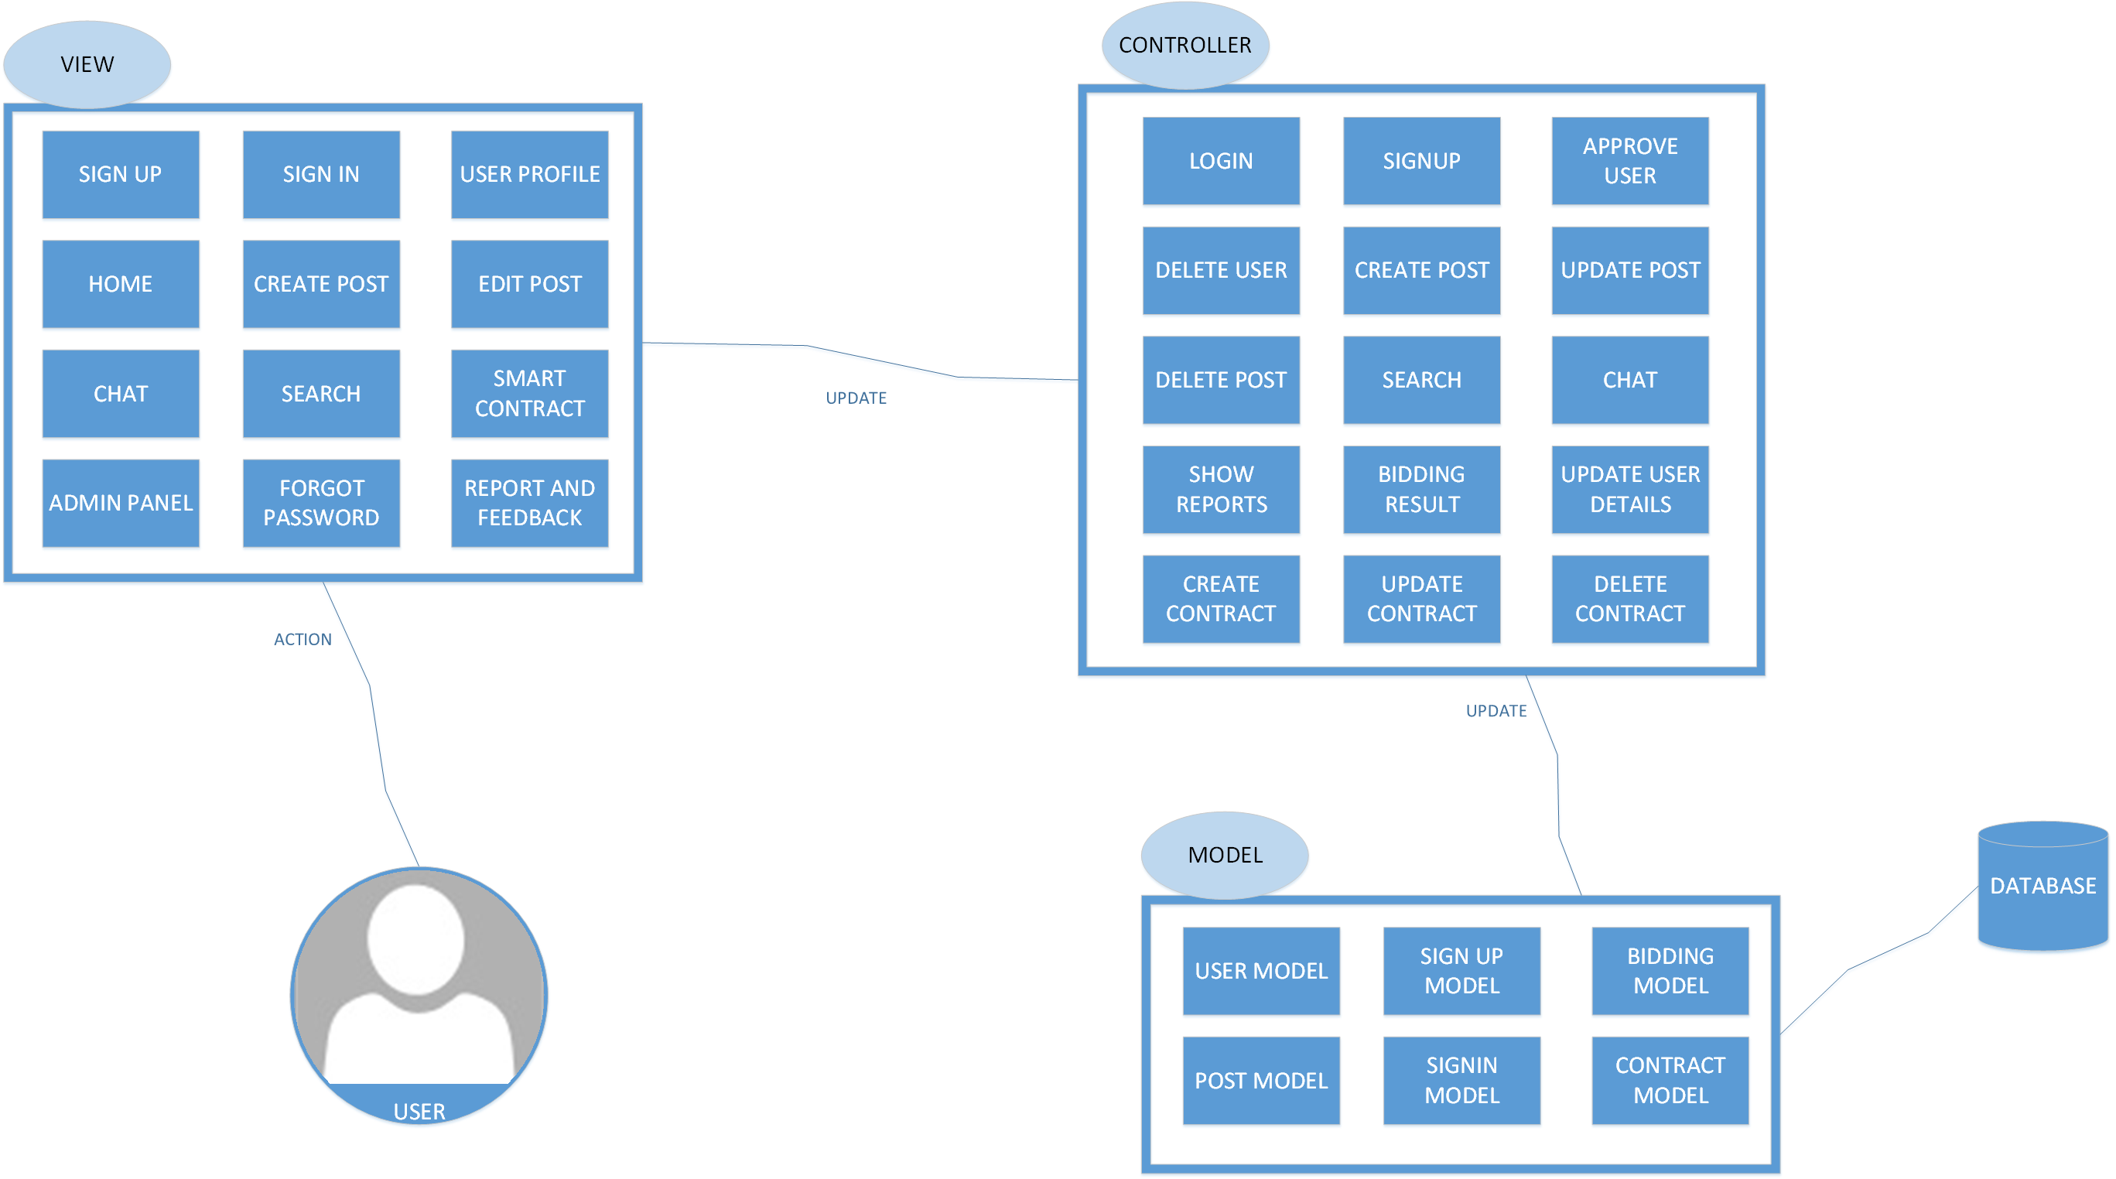

## Process Flow/Representation

This Process Flow depicts the Main functionalities of our system that a user can perform. For most of the activities the user has to be logged in to perform.

## Design Models

### Diagrams

This section would present the static structure of the system, its parts on different abstraction and implementation levels, and how they are related to each other. The elements in a structure diagram represent the meaningful concepts of a system, and may include abstract, real world and implementation concepts.

#### Class diagram

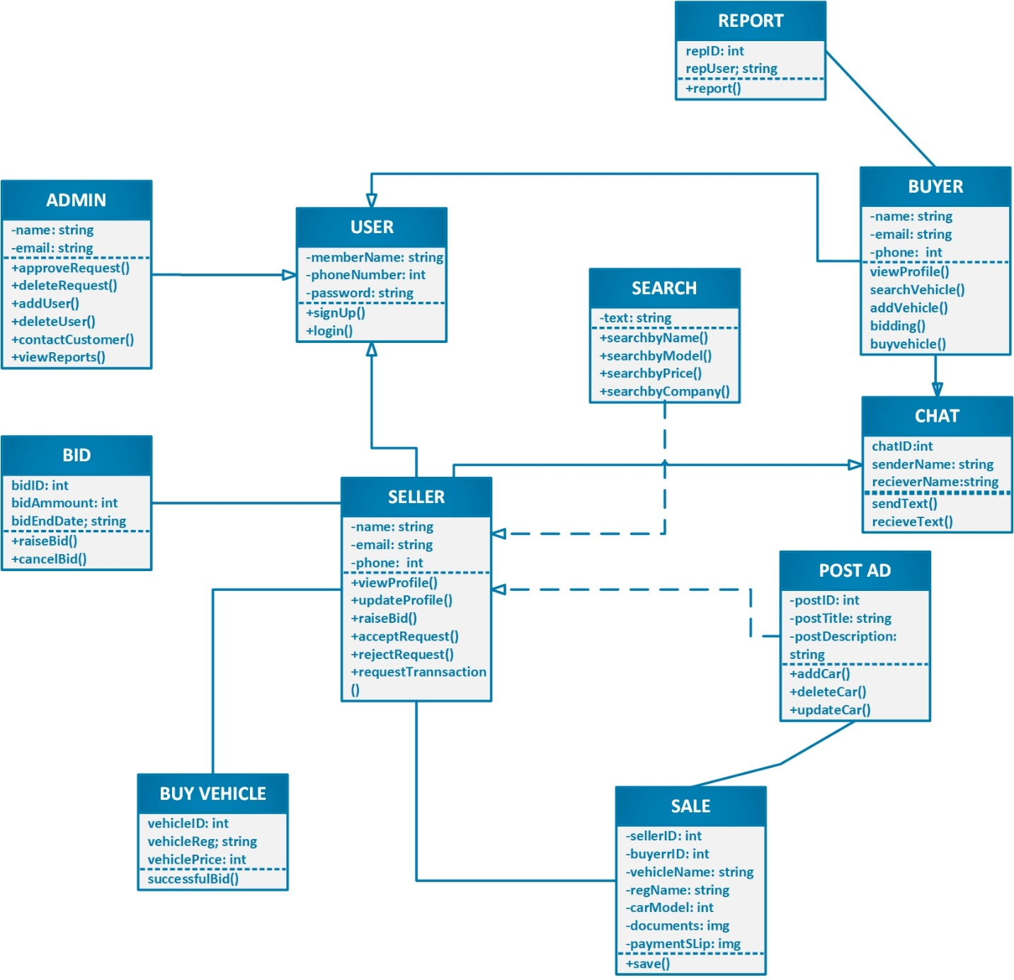

#### Activity diagram

### Sign in/Sign up

## 1

### Update Post

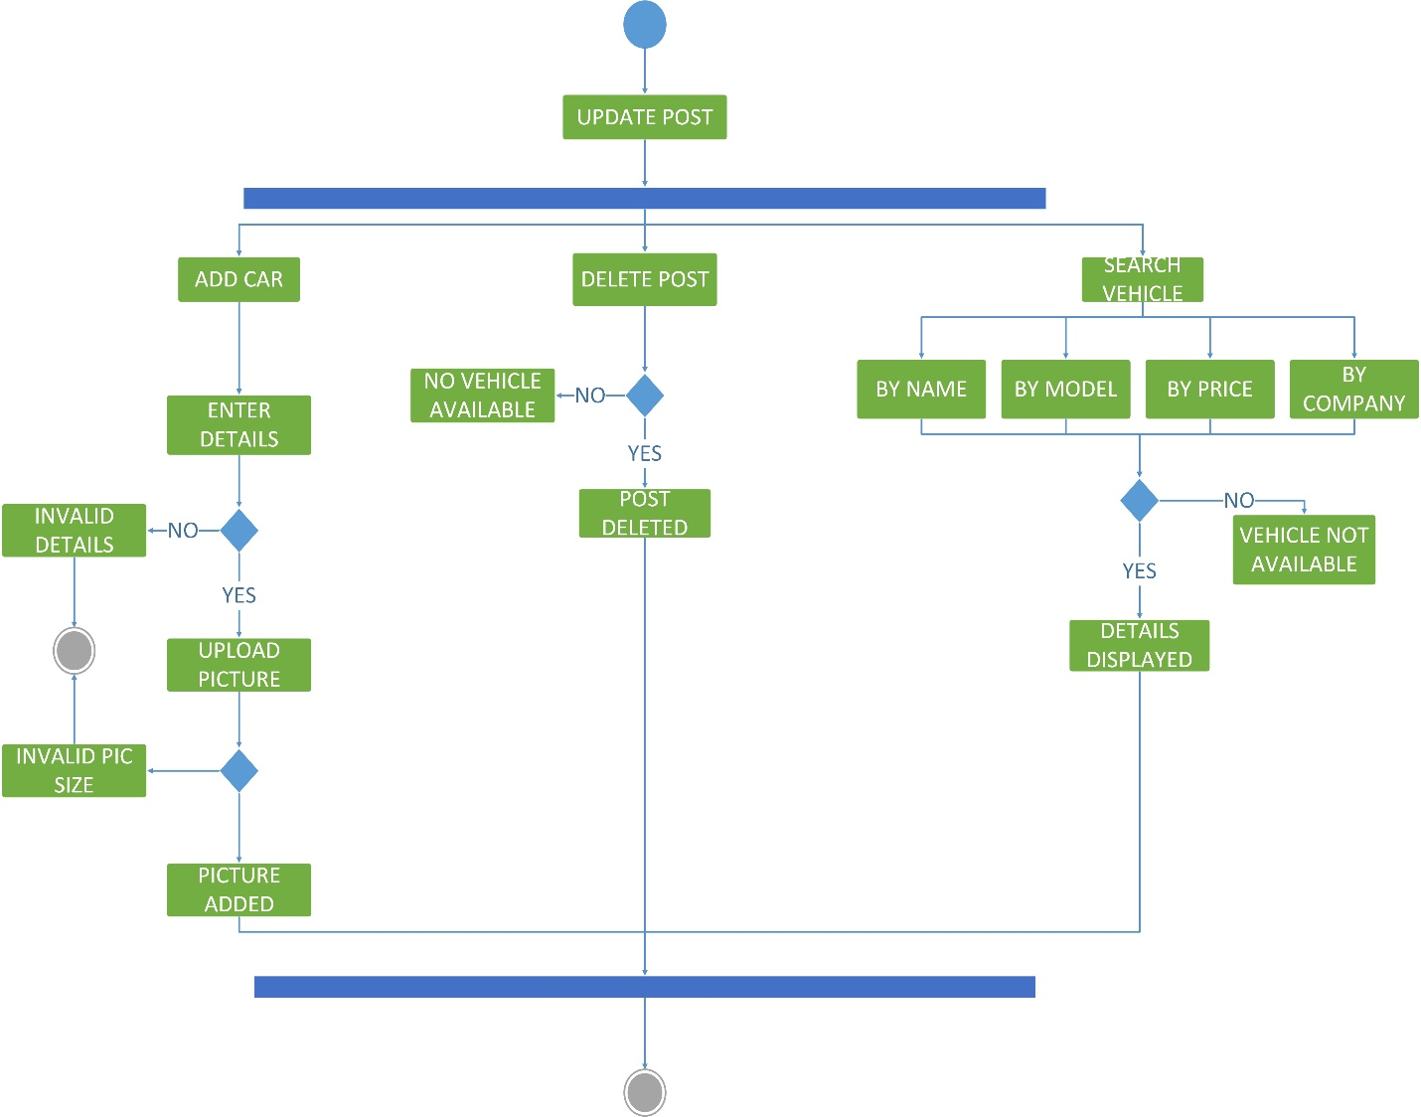

### Update Profile & Password

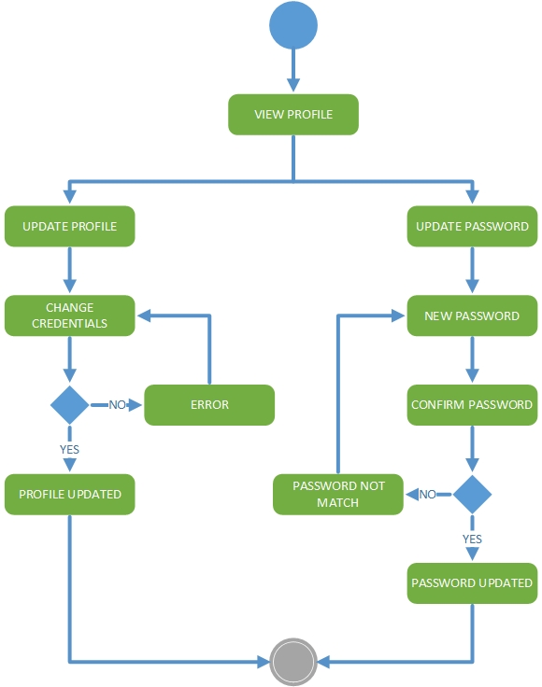

### Transaction Request

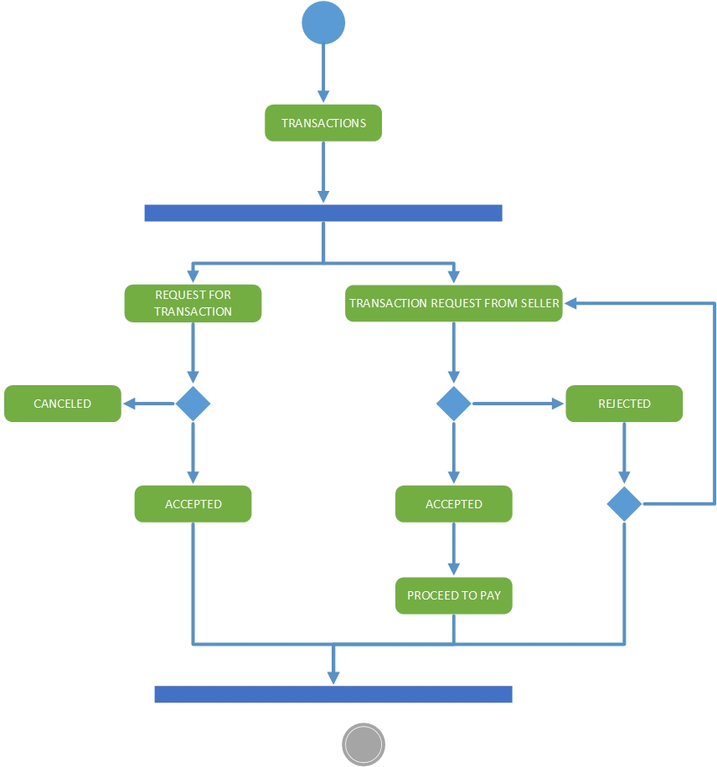

### Forgot Password

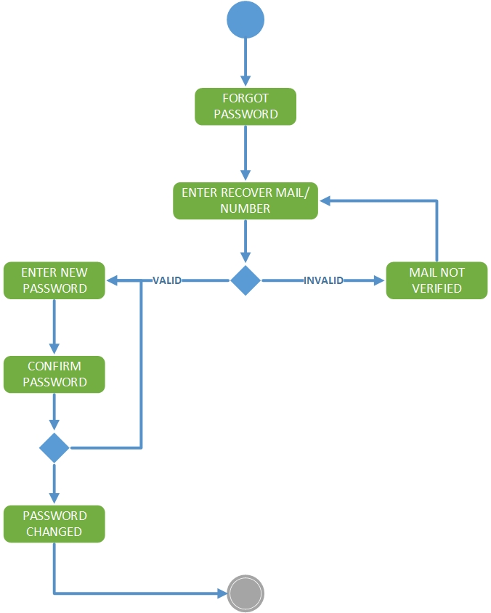

### Smart Contract

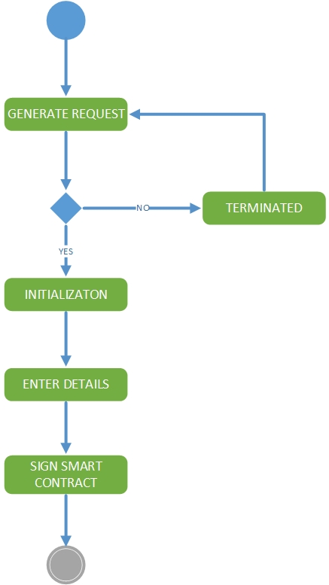

### Bidding

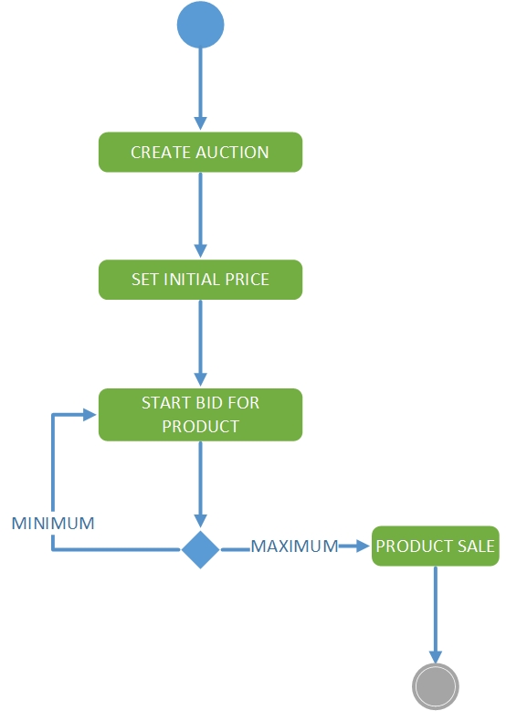

#### Sequence diagram

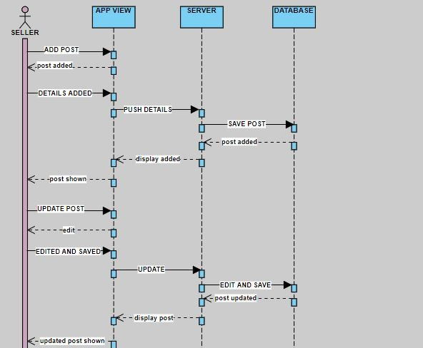

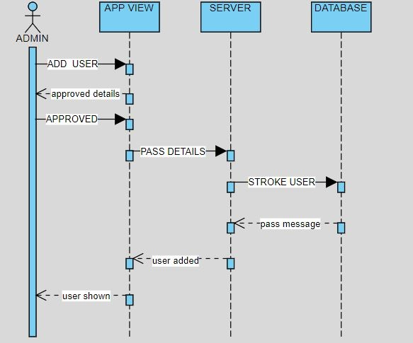

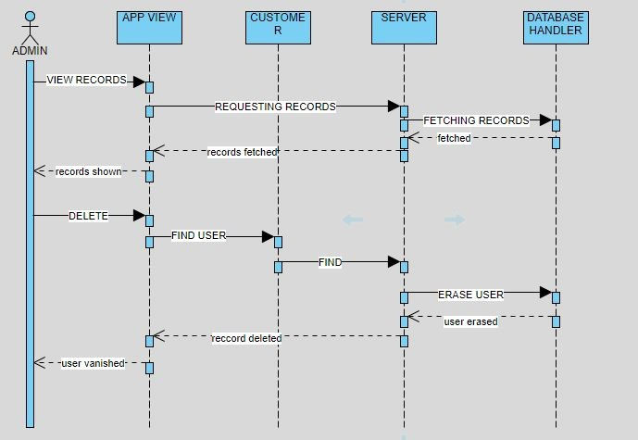

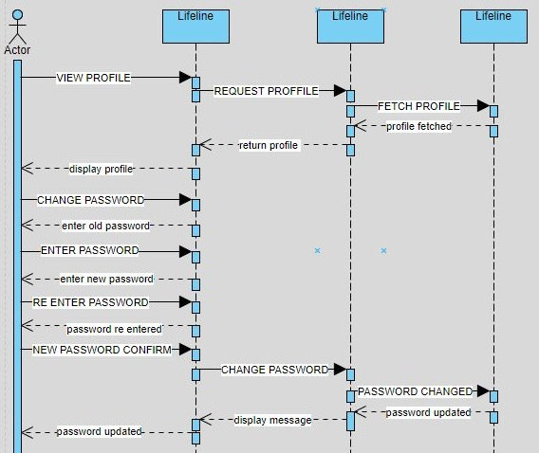

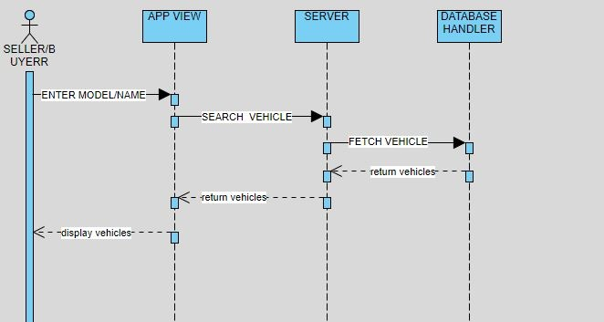

# Implementation

This chapter will discuss implementation details supported by UML diagrams (if applicable). You will not put your source code here. Any of the following sections may be included based on your project.



## Algorithm

## Signup implementation:

If cnic-number exists:

Prompt Error Invalid Credentials;

Else

Take credentials

Submit and send credentials to admin for approval

Locate user to home page

## Sign Smart Contract:

User request for smart Contract initiation:

If (user-req == true):

Then initiate smart contract;

Insert Secret key Seller and buyer;

Validate the smart contract;

If (validation == true):

Send smart to store;

Return smart contract successfully added and a unique address for smart contract;

# Software requirements traceability matrix

Table 1 Requirements Traceability Matrix

|  |  |  |  |
| --- | --- | --- | --- |
| **Req. Number** | **Ref. Item** | **Design Component** | **Component Items** |
| FR1 | Class Diagram | Customer | Signup |
| FR2 | Class Diagram | Customer | Login |
| FR3 | Class Diagram | Customer | Update profile |
| FR4 | Class Diagram | Customer | View profile |
| FR5 | Class Diagram | Customer | Reserve vehicle |
| FR6 | Class Diagram | Customer | Request transaction |
| FR7 | Class Diagram | Customer | Accept request |
| FR8 | Class Diagram | Customer | Reject request |
| FR9 | Class Diagram | Customer | Contact admin |
| FR10 | Class Diagram | User | Differentiate customer |
| FR11 | Class Diagram | Admin | Approve request |
| FR12 | Class Diagram | Admin | Delete request |
| FR13 | Class Diagram | Admin | Delete user |
| FR14 | Class Diagram | Admin | Contact customer |
| FR15 | Class Diagram | Book | Book inspection |
| FR16 | Class Diagram | Book | Delete booking |
| FR17 | Class Diagram | Book | Edit booking |
| FR18 | Class Diagram | Save Sale | Upload documents |
| FR19 | Class Diagram | Reports | Total sales |
| FR20 | Class Diagram | Reports | Pie chart |
| FR21 | Class Diagram | Reports | Bar chart |
| FR22 | Class Diagram | Smart Contract | Fill contract |
| FR23 | Class Diagram | Smart Contract | Sign contract |
| FR24 | Class Diagram | Smart Contract | Validate contract |
| FR25 | Class Diagram | Smart Contract | Save/submit contract |
| FR26 | Class Diagram | Search | Search by name |
| FR27 | Class Diagram | Search | Search by model |
| FR28 | Class Diagram | Search | Search by company |
| FR29 | Class Diagram | Search | Search by engine |
| FR42 | Class Diagram | Post | Add post/car |
| FR43 | Class Diagram | Post | Edit post/car |
| FR44 | Class Diagram | Post | View |
| FR45 | Class Diagram | Post | delete post/car |
| FR46 | Class Diagram | Update Post | update post/car |
| FR47 | Class Diagram | Delete Post | delete post/car |
| FR48 | Class Diagram | Update Profile | Update |

# Human interface design

The user can Sign up using the signup form and the details would be sent to the admin for manual approval, once the user account has been approved the user can login and create a post or contact another buyer/seller. User can edit their profile from the profile menu. User can chat with other people through the chat app provided by the system, the Buyer and Seller would Request Transaction (Execution of Smart Contracts) and by bidding system the vehicle is selected. Once they have signed the smart contracts with their private keys, the final data would be save.

# Conclusion and Future Work



## Conclusion

This web application will provide a secure and efficient online market to users. This app will provide verified cars and motorcycles and also a secure transfer of money and ownership. And also provide installment program to those people who cannot afford to pay all money at once.

## Future Work

In the future, we are planning to take our project as a product and use it in the market because it is a good project with many benefits in different industries.

# References

https://www.wikihow.com

<https://www.lucidchart.com>

<https://en.wikipedia.org/wiki>